MA eCAS / CANS
End-User Training & Quick Reference Guide
Screenshot-based guidance for common member, assessment, staff, and support workflows
Version 8/20/2026 | Audience: CANS Certified Assessors, Data Entry Operators (DEOs), and Organization Administrators
Purpose Use this guide while working in eCAS to locate the correct screen, complete common Member and assessment tasks, and route issues to the appropriate support team.
QUICK TASK INDEX
Quick task | Section | Page
Security-question prompt | 1 | 2
Search / add Member | 2 | 3-5
Assessment guardrails | 3 | 6
DEO → Certified Assessor review | 4 | 7
Add Certified Assessor position | 5 | 8-10
Filter staff | 6 | 11-13
Print / save PDF | 7 | 14-15
Cancel / expiry / reassessment | 8 | 16
Special cases / WellSky basics | 9 | 17
Access / registration / support | 10 | 18
End-user checklist | 11 | 19
Screen-label note Screen labels may vary by configured eCAS environment. Follow the labels displayed in your organization’s environment.

1. Accessing eCAS: Security-Question Popup
1. If a security-question setup dialog appears while accessing the Virtual Gateway for eCAS, do not complete the setup from this dialog.
2. Click Cancel.
3. Continue into eCAS.
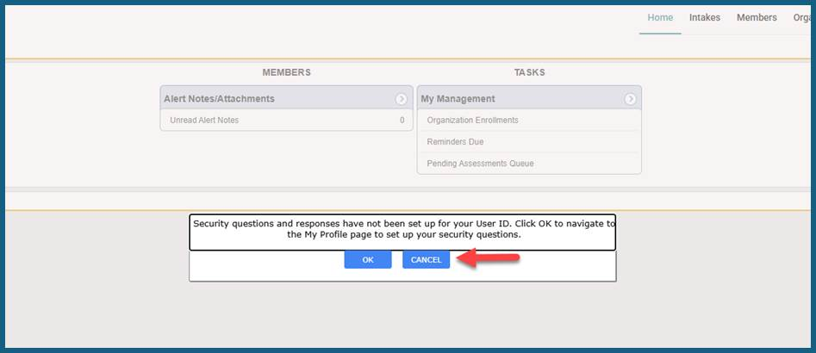
Figure 1.1 — Security-question dialog: select Cancel.
Browser setup — Allow pop-up windows for WellSky. Pop-up windows are required for certain application functions.

2. Search for a Member and Add a New Member
Important — Create a new Member record only after the Member search confirms that no matching record exists.

2.1 Search for the Member
1. Open the Members chapter.
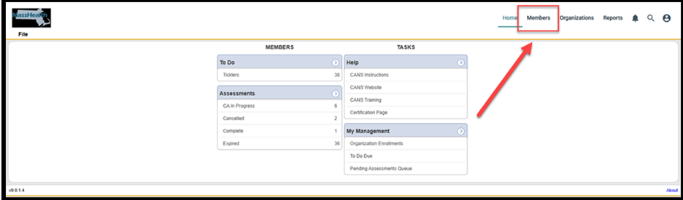
Figure 2.1 — Members chapter entry point.
2. On Advanced Search, enter the entire 12-digit MassHealth ID, the first two letters of the Member’s last name, and the Member’s date of birth (DOB).
3. Click Search. If only one record is returned, the Member record opens automatically.
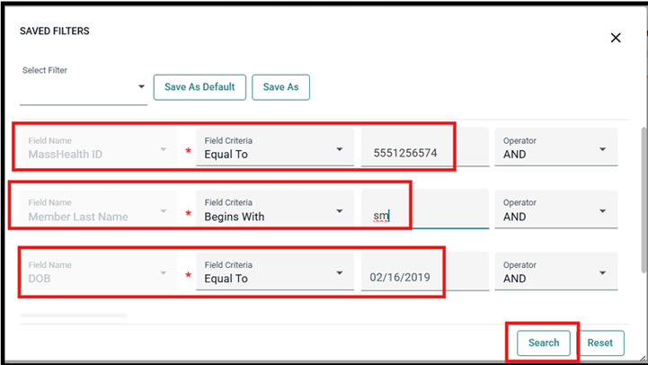
Figure 2.2 — Advanced Search criteria: MassHealth ID, Member Last Name, and DOB.

MMIS status — If the current MMIS status is not reflected, use Members > Add New Member Search instead of Quick Search to retrieve the most current information from MMIS.

2.2 Add a New Member When No Match Is Found
1. Confirm the Advanced Search results show zero members returned.
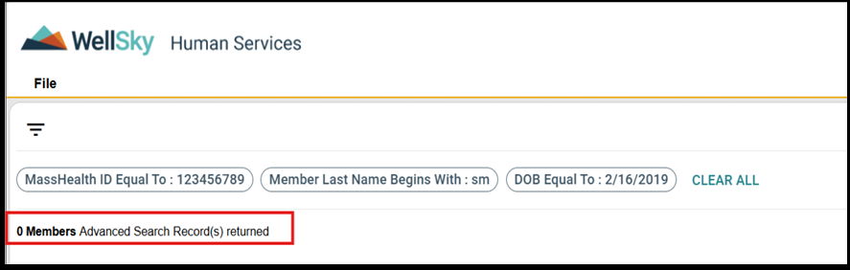
Figure 2.3 — Zero-match search result.
2. Select File > Add New Member Search.
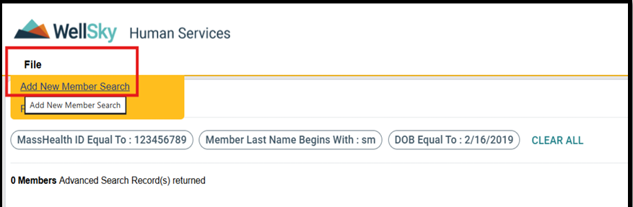
Figure 2.4 — File menu > Add New Member Search.
3. Re-enter the Member search information and click Search to reconfirm that no Member exists.
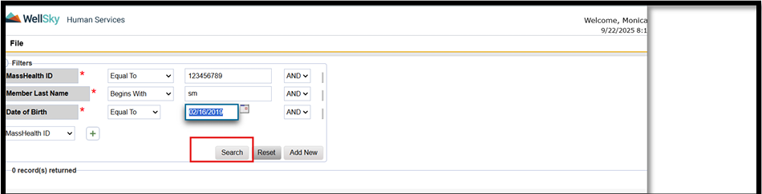
Figure 2.5 — Reconfirm member search before adding a new Member.

4. If no match is found, click Add New.
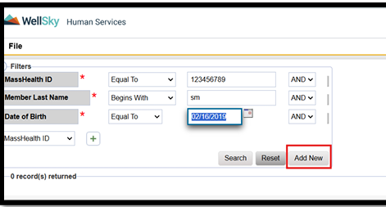
Figure 2.6 — Add New button after zero-match confirmation.
5. Review the Demographics Summary. Information retrieved from MMIS cannot be edited in eCAS.
- MMIS-sourced fields include MassHealth ID, first/middle/last name, suffix, ethnicity, primary language, race, gender, and date of birth.
6. To add an assessment, open the Assessments tab and select File > Add Assessment.
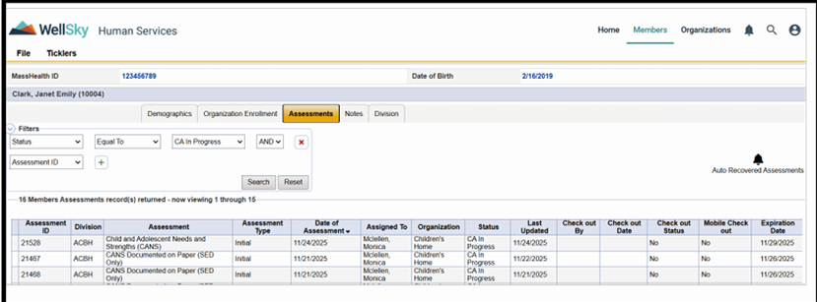
Figure 2.7 — Member Assessments tab and Add Assessment entry point.

3. Assessment Guardrails Before You Start
Check | Rule
Member age | A new CANS Assessment cannot be created or saved for a Member age 21 or older.
MMIS status | An assessment cannot be saved when the Member is not an Active MMIS Member.
Reassessment | A completed Initial Assessment must already exist for the same Organization and Level of Care.
Discharge | A completed Initial Assessment must already exist for the same Organization and Level of Care.
Open assessments | An in-progress Initial, Reassessment, or Discharge for the same LOC / Organization can block creation of another assessment type.

Member age 21 or older
- The application prevents a new assessment from being saved.
- For an existing assessment, use Status = Cancelled and Reason = Member over 21.
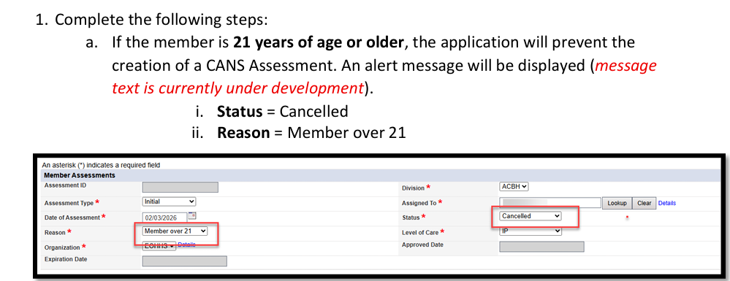
Figure 3.1 — Example cancellation for Member over 21.

Assessment created for the wrong Member
- Cancel the assessment with Status = Cancelled, Reason = Other, and Additional Reason = “CANS saved for incorrect member.”
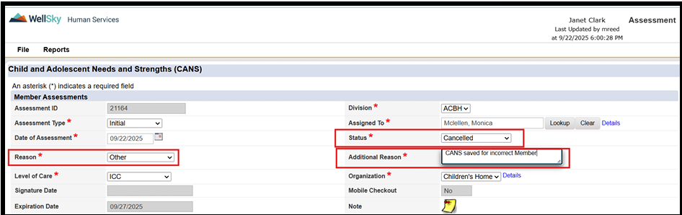
Figure 3.2 — Example: cancel an assessment saved for the incorrect Member.

4. DEO → Certified Assessor Review Workflow

4.1 DEO submits for Certified Assessor review
1. Complete the required CANS data entry.
2. Update Assigned To back to the CANS Certified Assessor.
3. Change Assessment Status to the configured CA-review status (the screenshot shows Awaiting CA Review), then save/submit.
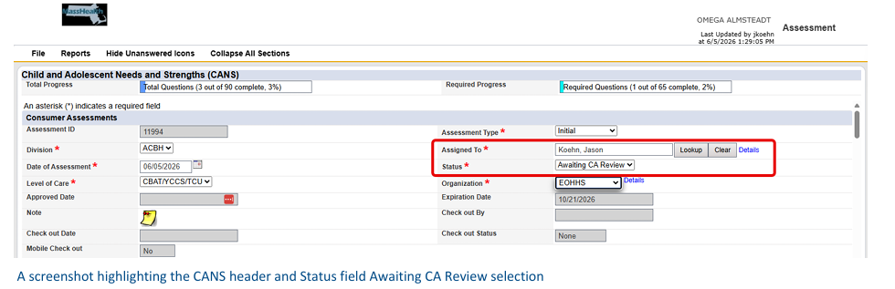
Figure 4.1 — DEO submission: Assigned To = Certified Assessor; Status = Awaiting CA Review.

4.2 Certified Assessor review
1. When review begins, update the status to Under CA Review and save before completing the review.
2. If approved, update the status to Complete or Incomplete, as appropriate.
3. If revisions are needed, update the status to Rejected and reassign the assessment to the DEO.
- Create a Note with Note Type = CANS – Review Rejected, describe the revisions, and add the DEO as the Note Recipient.
- The DEO sees the note under Members > Notes > Complete on the Home page.
Need more information? — Use Note Type = “CANS – Needs More Information,” describe what is missing, and add the Certified Assessor as the Note Recipient.

5. Add a Certified Assessor Position to a Staff Record
1. Go to the Organizations chapter.
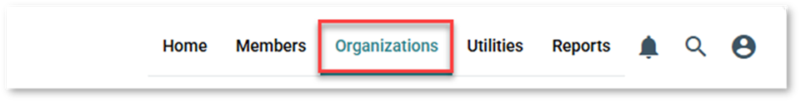
Figure 5.1 — Organizations chapter.
2. Select the Staff tab within the Organization record.
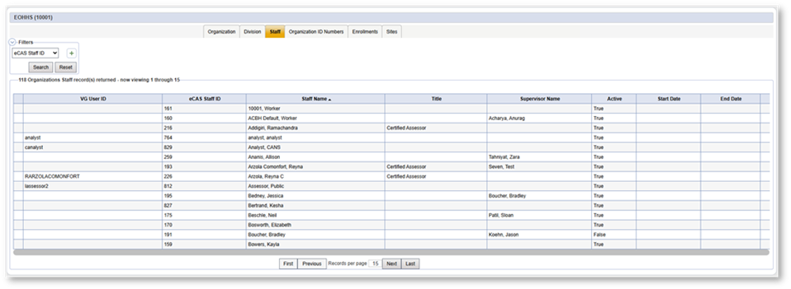
Figure 5.2 — Organization record > Staff tab.
3. Select the staff member. Open Positions from the menu on the left. If the staff member does not exist, add the staff record first.
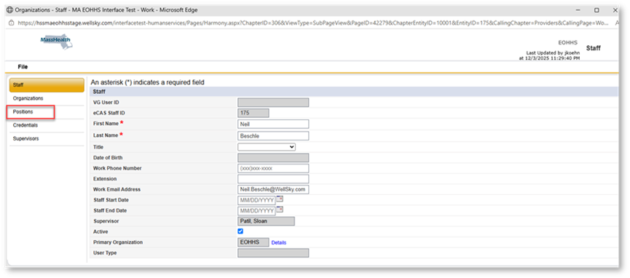
Figure 5.3 — Staff record > Positions.

4. Select File > Add Position.
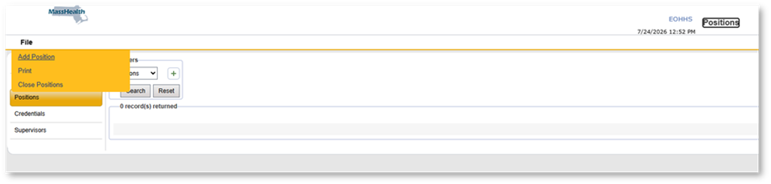
Figure 5.4 — File menu > Add Position.
5. From the Position dropdown, select Certified Assessor.
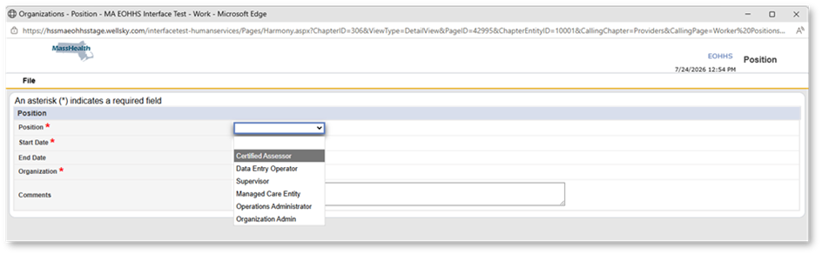
Figure 5.5 — Position dropdown > Certified Assessor.
6. Enter the staff Start Date and Organization. Only organizations associated with the staff member appear in the dropdown.
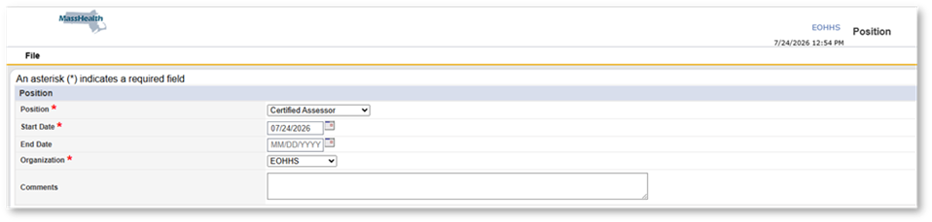
Figure 5.6 — Enter position details.

7. Select File > Save and Close Position.
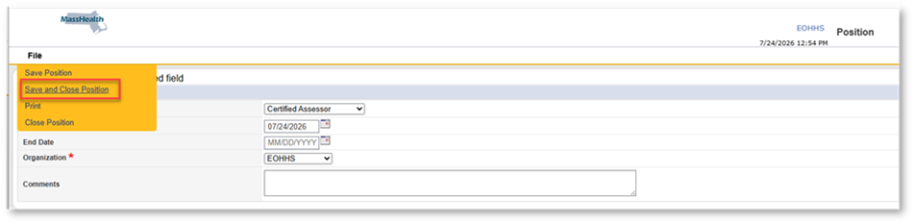
Figure 5.7 — Save and Close Position.
8. Confirm the Certified Assessor position appears in the Positions list.
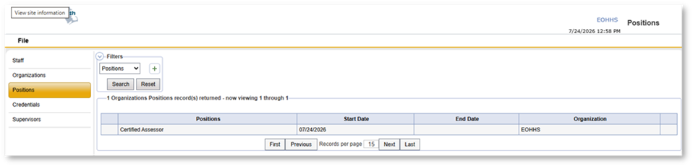
Figure 5.8 — Positions list after saving.
“Not a Certified CA” error — After CANS certification, the eCAS CANS Organization Administrator or Supervisor must add the assessor’s CCS Credentials. Confirm the required position and credentials are set up before escalating.

6. Filter Staff in the Organization Chapter
1. Navigate to the Staff tab.
Figure 6.1 — Staff tab.
2. Use the filter dropdown in the upper-left corner.
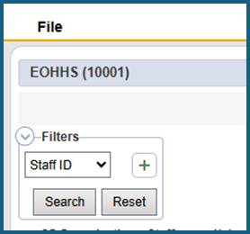
Figure 6.2 — Staff filter control.
3. Select Active and click the plus (+) sign.
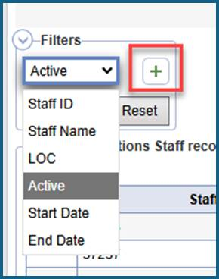
Figure 6.3 — Add the Active filter.

4. Select Staff Name and click the plus (+) sign.
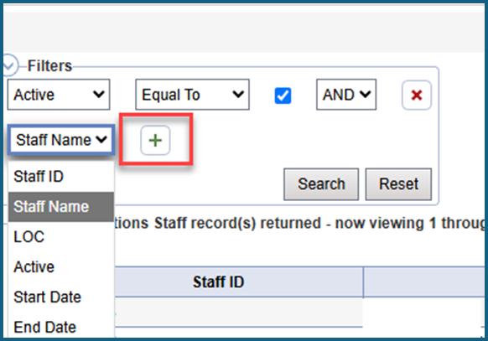
Figure 6.4 — Add the Staff Name filter.
5. Choose a search operator such as Equal To, Begins With, Ends With, or Contains.
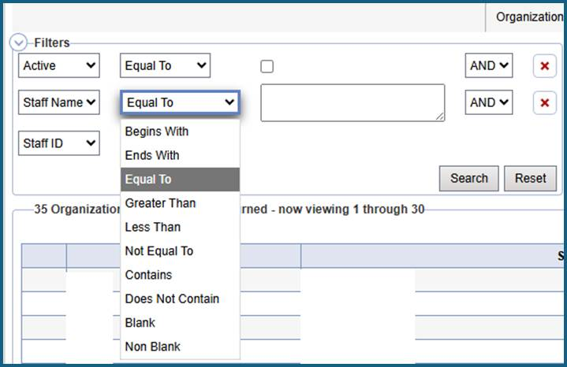
Figure 6.5 — Available Staff Name search operators.
6. Enter the search criteria and click Search.
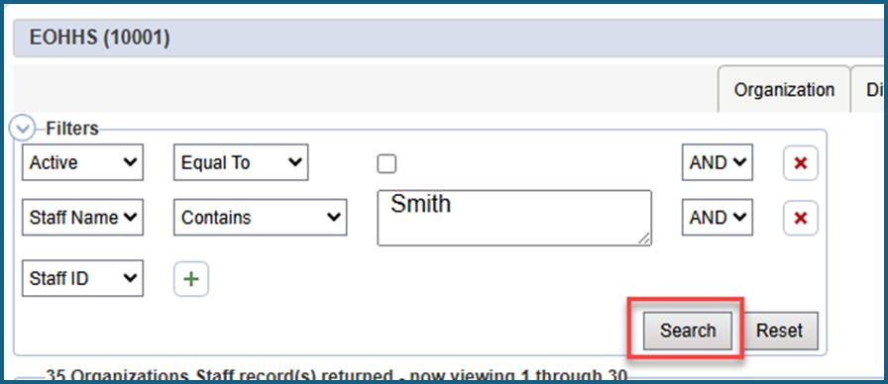
Figure 6.6 — Example: Staff Name Contains “Smith”.
Organization Enrollment Staff — Manually add staff when an Organization Enrollment record already exists for the logged-in user’s organization but the user is not yet assigned to the Member.

7. Print an Assessment or Save It as PDF
1. Select File > Save and Close Assessment.
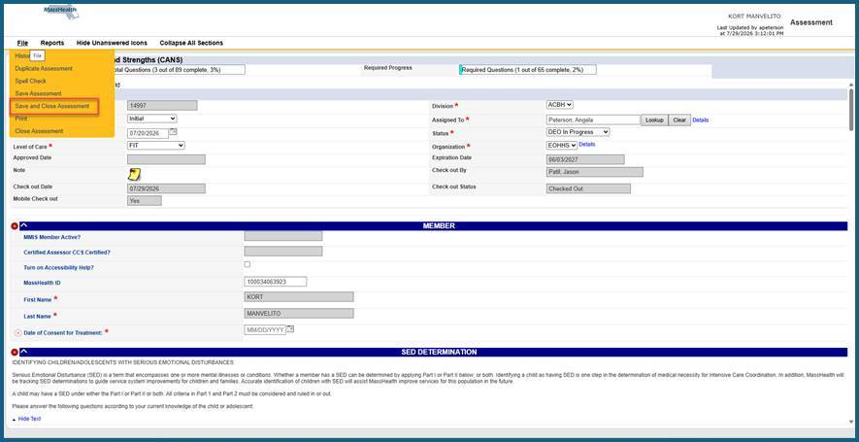
Figure 7.1 — Save and Close Assessment.
2. Reopen the Assessment and select File > Print.
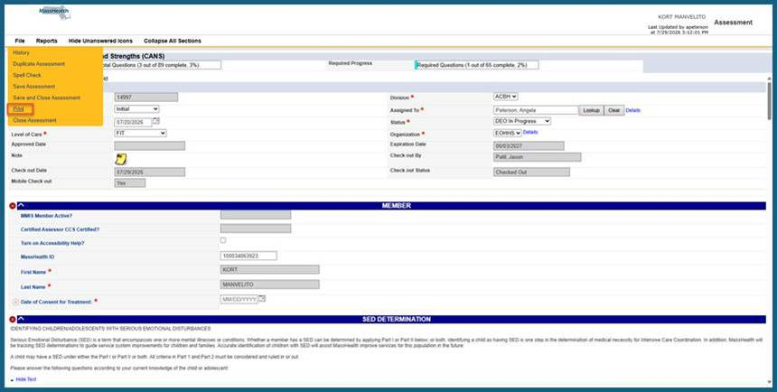
Figure 7.2 — Reopen the Assessment and select Print.

3. In the browser print dialog, select the destination printer or a PDF destination, as available in your environment.
4. Click Print or Save, depending on the selected destination.
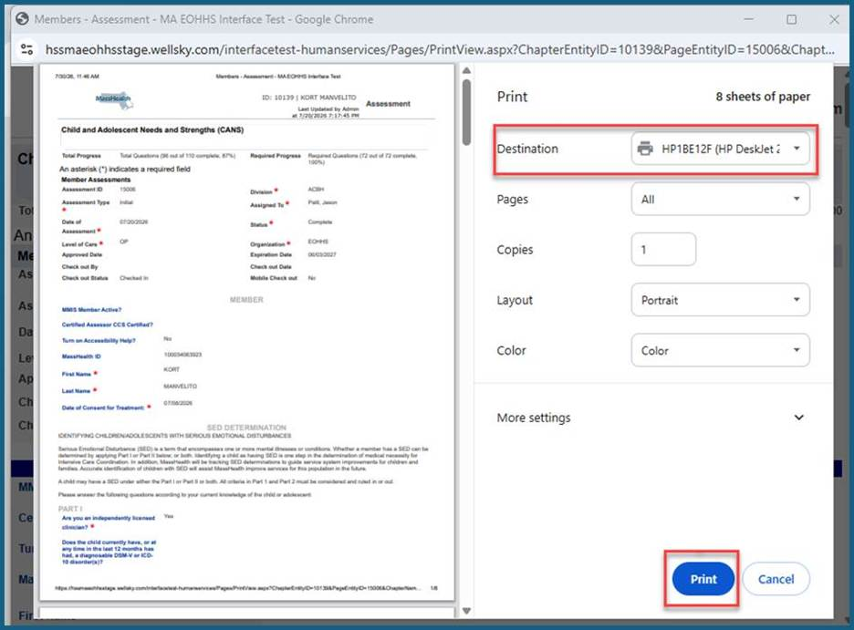
Figure 7.3 — Browser print dialog.
Tip — Use File > Save and Close to reduce screen stacking and prevent multiple WellSky screens from blocking navigation.

8. Cancel, Expire, Reassess, Discharge, or Duplicate

Cancellation
Situation | What to do
Assessment not yet saved | Click Close Assessment. The assessment will not be saved.
Unable to Contact | Cancel using the corresponding cancellation reason.
Refused to Answer | Cancel using the corresponding cancellation reason.
Member Over 21 | Cancel using Reason = Member over 21.
Other | Select Other and enter an Additional Reason.
Incorrect Member | Status = Cancelled; Reason = Other; Additional Reason = “CANS saved for incorrect member.”

Expiration and follow-up
- Assessments left in CA In Progress, DEO In Progress, Awaiting CA Review, Under CA Review, or Rejected automatically expire after 318 calendar days.
- Once an assessment is saved as Complete, a 180-business-day WFW/Tickler is triggered to remind the Certified Assessor about the next Reassessment.

Reassessment / Discharge / Early Reassessment
- Discharge: no required waiting period; it may be completed as soon as the Member stops receiving services.
- Early Reassessment: no required waiting period; use Assessment Type = Reassessment when the clinician learns something has changed.
- Duplicate Assessment: copies a previously completed assessment to streamline data entry; the copied assessment still requires review and updates before submission.

9. Special Cases and WellSky Basics

CANS Documented on Paper (SED Only)
- Only a CANS Certified Assessor can create this assessment type; it is not available to a DEO under Add Assessment.
- Available LOCs: IP, CBAT/YCCS/TCU, FIT, ICC, IHT/IHBS, and OP.
- Completion windows: ICC 10 calendar days; IHT/IHBS 21 calendar days; FIT 180 calendar days; OP 180 calendar days, measured from Date of Consent for Treatment.
- SED Only is for Initial assessments only. This restriction is not system-enforced, so training and supervisory controls must prevent use for Reassessment or Discharge.
Paper CANS — MassHealth is not publishing a paper CANS at this time and expects most, if not all, CANS to be entered in eCAS. For an extreme circumstance, follow your organization’s approved process.

WellSky navigation habits
- Allow browser pop-ups for WellSky.
- Use File > Save and Close instead of only Save to reduce screen stacking.
- Use File > History on most pages to see who changed a page and what changed.
- If you have multiple roles, select the Person icon, choose the correct role, and click Apply.

10. Access, Registration, and Support Routing
Support Category | Issues / Inquiries Covered | Contact / Resolution Path
CANS Training | • Certification Key Issues  • Exam Resets | MassCANS@umassmed.edu  774-455-4057
Virtual Gateway (VG) | • VG Login Issues  • Accessing CANS in VG  • Name Changes in VG  • User Registration Form (URF) | 1-800-421-0938
e-CAS Technical Support (EHR) | • EHR Integration | EHS-MA-ECAS-IT@mass.gov
e-CAS Technical Support (Setup & Forms) | • e-CAS System Setup  • e-CAS Forms + Processes | EHS-MA-ECAS-IT@mass.gov
Using CANS in Practice | • Questions about specific issues when using CANS in practice  1. Review training documentation  2. Speak with your supervisor or org admin. | CANS-CBHI@state.ma.us

Quick troubleshooting sequence
1. Confirm the correct eCAS role is selected.
2. Confirm browser pop-ups are allowed and unnecessary WellSky screens are closed.
3. For Member/MMIS issues, use the Members Advanced Search / Add New Member Search workflow.
4. For Certified Assessor access errors, verify required staff position and CCS credential setup.
5. Route the issue to the support team above with the relevant Member/assessment context permitted by your organization’s privacy practices.

11. One-Page End-User Checklist

Before creating an assessment
- Search for the Member using MassHealth ID, first two letters of last name, and DOB.
- Confirm the correct Member record and active MMIS status.
- Confirm the Member is under age 21.
- Confirm there is no conflicting in-progress assessment for the same Organization / LOC.
- For Reassessment or Discharge, confirm a completed Initial exists for the same Organization / LOC.

Before DEO submission
- Complete required CANS fields.
- Assign the assessment back to the Certified Assessor.
- Select the CA-review status configured in your environment (the screenshot shows Awaiting CA Review).
- Save/submit and confirm the assessment leaves DEO work as expected.

Before Certified Assessor completion
- Set Under CA Review and save before review.
- Review entered values and required sections.
- Approve as Complete/Incomplete, or reject and reassign to the DEO.
- If rejected, document required changes in a CANS – Review Rejected note and add the DEO as recipient.

Before closing the screen
- Use File > Save and Close.
- If printing, reopen the assessment and use File > Print.
- Use History when you need to confirm prior changes.
Final check — Use the screenshots to confirm that you are on the correct screen before selecting actions that change Member, staff, or assessment records.

