VIRTUAL ECHO AUTISM and INTELLECTUAL AND DEVELOPMENTAL DISABILITY (IDD) TRAINING
for Child and Adolescent Mental Health CBHC Clinicians

This free and interactive virtual training program will increase your knowledge about autism and IDD, the unique needs related to caring for these patients who have comorbid psychiatric disorders and how to communicate across systems.
Faculty

- Sarah J. Palmer, MD
- Sarah Friel, MA, CCC-SLP
- Angela Bryson, MA., BCBA
- Elizabeth Turenne, LICSW

Date Time Topic
1/13/2027 9am – 10:15am Autism/IDD Overview
1/27/2027 9am – 10:15am Medical Comorbidities
2/10/2027 9am – 10:15am Psychiatric Comorbidities
2/24/2027 9am – 10:15am Communication
3/10/2027 9am – 10:15am De-escalation
3/24/2027 9am – 10:15am Supporting the Family
4/7/2027 9am – 10:15am Behavior Basics
4/28/2027 9am – 10:15am Assessing Agitation
5/5/2027 9am – 10:15am Impact of Trauma
5/19/2027 9am – 10:15am Preparing the Environment
6/2/2027 9am – 10:15am Elements of Safety
6/16/2027 9am – 10:15am Prescribing
Registration Fee for the Educational program: FREE

Fee for those Physicians $75
That want Credit Nurses $50 Psychologist $95
Social Worker $45
MA LMHC $45

Application for Psychologist, Social Worker and MA LMHC continuing education credits have been submitted. Please note that partial credit is not available for psychologist, Social Workers and LMHCs. All 12 sessions need to be attended.

Application for Nursing Continuing Education credits and for Physician and Physician’s Assistants Continuing Medical Education credits have been submitted through UMASS Chan Medical School. Physicians, PAs and Nurses can get credit for any number of the sessions attended.

For questions regarding the training or regarding CEs or CMEs, please email ShriverCenterTrainings@umassmed.edu

To register for this program, please go to the following URL:

Continuing Education (CEs) and Continuing Medical Education (CMEs) Programs and Trainings

Or use this QR code:

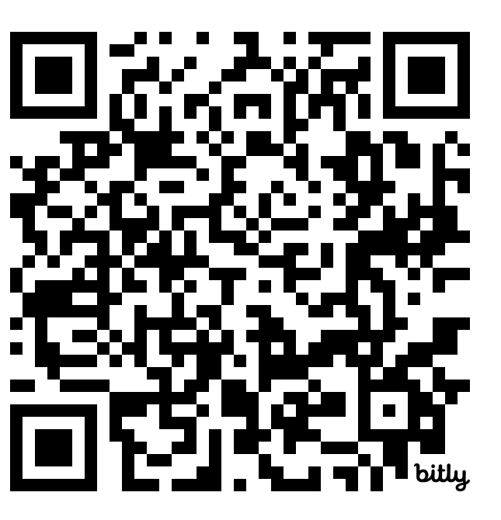

You will be given the opportunity to indicate that you would like to receive credit and a certificate at that URL.
The Deadline for registration is January 5th, 2027.

* Please note that certificates will not be issued until all course requirements have been completed and verified.

Who can take the ECHO Autism and IDD Training?
All Massachusetts CBHC Child and Adolescent
Mental Health Team Members.
Where will it take place?
This a FREE 15-hour training. The sessions occur
every other week for 1 hour & 15 minutes over
6 months. Sessions are held via Zoom video
conferencing and will include Case Presentations
with discussion amongst attendees. Each session
will have a high yield slide didactic.

What topics are included?
The high yield didactics (or knowledge bursts) include:
- How to apply best practice care for those with autism and/or IDD who are experiencing a behavioral
health concerns.
- How to communicate with these individuals and across systems involved in caring for them.
- What psychiatric and medical comorbidities, evidence-based interventions, and systems of care exist
for those with autism and/or IDD.

How do I register?
Go to the URL or QR code provided on this flyer. You will receive an introductory email with program tips
and expectations prior to the first session and be sent calendar invites with zoom links.
If you need help registering, please email: ShriverCenterTrainings@umassmed.edu.
Questions? Contact: Lauren Venuti, MSW, Program Director, ECHO Autism Crisis Care Training * E.K.
Shriver Center, UMASS Chan Medical School: Lauren.Venuti@umassmed.edu


