Health Promotion and Aging in Adults with Intellectual and Developmental Disabilities
Resources
Nutritional Resources
My Plate
A practical source of information and guide to help individuals help find healthy eating solutions.
Center for Disease Control and Prevention
Offers support for public health strategies and programs that improve dietary quality, support healthy development, and reduce chronic disease.
More Matters
An online campaign that helps people eat more fruits and vegetables by providing recipes and supports.
MassLeague.org
A comprehensive list of health centers in Massachusetts that include nutritionists who are available for inexpensive consultations and classes
Grocery Store Nutritionists
Grocery store chains such as Stop & Shop and BigY have in-store nutritionists who offer free advice, classes, and shopping demos periodically. Visit your local grocery store to inquire about nutritionists on staff.
Physical Activity Resources
The ARC
Advocacy organization for individuals with IDD that offer community based therapeutic recreations including cooking classes, walking clubs, basketball clinics, boot camp exercise classes, and aquatics.
YMCA
May offer inclusive programs like adaptive swimming.
Department of Conservation and Recreation
The Universal Access Program offers outdoor recreation opportunities for people of all abilities.
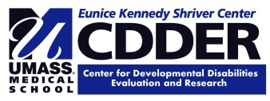
Disabilityinfo.org
INDEX website offers listing of recreational opportunities for people with disabilities.

