Responsibilities in Action: Massachusetts MAP Certification Training

Student Manual

Getting Started
Students will receive a welcome email with course access permission and instructions on the morning of the first day the course opens. Sometimes the email will go directly to a spam or junk folder. Please look for an email from Admin User (via Massachusetts Medication Administration Program Training Resources and Support) <noreply@neindex.org> Follow instructions in the email. Please email CDDER@umassmed.eud if you do not receive an email on the day your course starts.

Resource Packets
Students must have a Resource Packet for this course. Please coordinate with your MAP Trainer or Provider agency to obtain one. Please note: Students must have blister packs for the activities; images of blister packs may not be used.

Course Technology
This course is built in Moodle.

Browser support:
Moodle is compatible with any standard compliant web browser. Moodle works best with the following browsers:
Desktop: Chrome, Firefox and Safari. This course has not been fully tested in the new browser Edge.
Mobile (smart phones or tablets) Internet Browsers: Mobile Safari, Google Chrome
For the best experience and optimum security, we recommend that you keep your browser up to date.
To get started, go to:
- Site Name: (https://mapmass.com/): MAP Mass
- Log into MAP Mass Online by clicking the “Log in” button which is located in the upper right corner of the homepage.
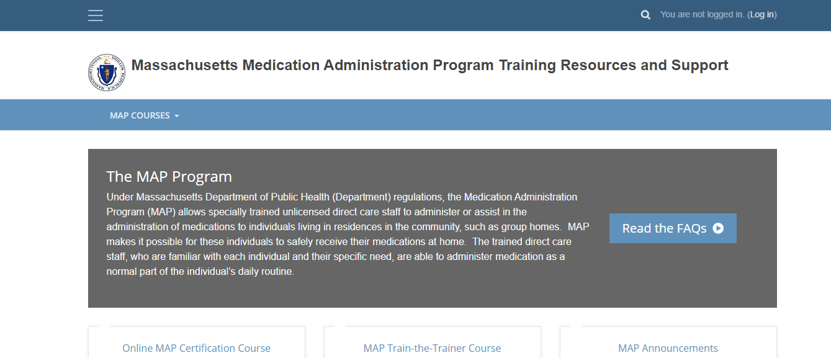

- Enter the Username and Password that was in the email you received. Click the blue “Log in” button:
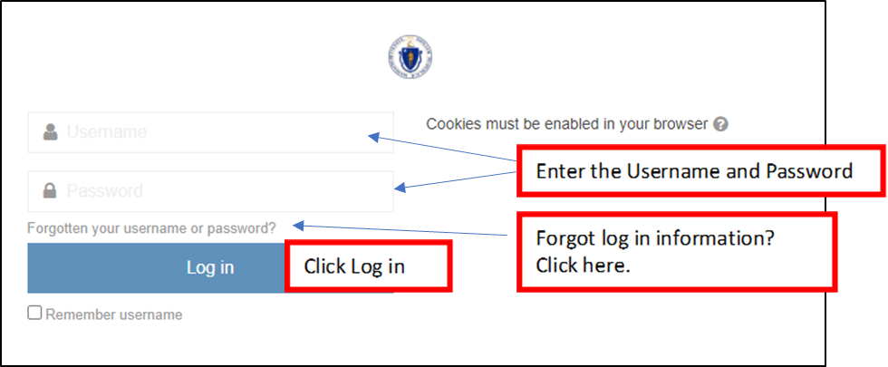

The password you are given to log in for the first time is a temporary password. Once you are logged in successfully, the system will prompt you to change it to something different for all future log ins.
- Your username to login is created by CDDER and contains your first initial and full last name (some will contain a middle initial, birthdate or random number to make sure there are no duplicates), you do not use your email to login.

How do I Reset My Password?
- If you forget your password, click on the “Forgotten your username or password?” link (shown in the image above).
  - The system will send you a link with instructions on how to reset it
  - If you are still having issues logging into your account, please contact CDDER@umassmed.edu

What do I do if my name is misspelled in Moodle or I need to change my email address?
- If your name is misspelled or you need to change your email address, you can change it under your profile settings
  - From the menu at the top right, click on “Profile”
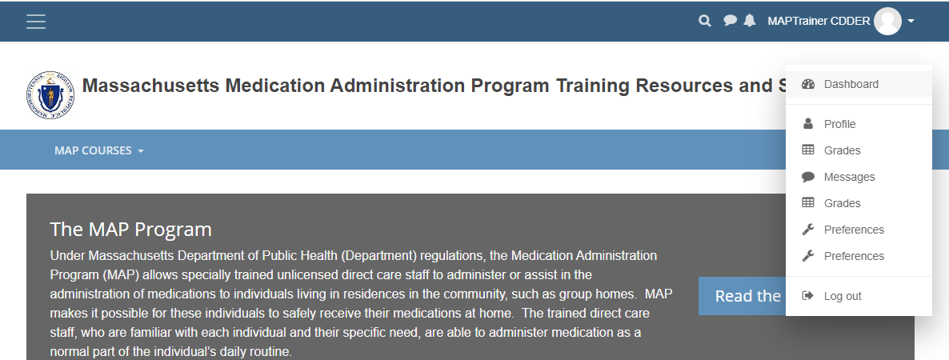

  - Under “User Settings” click on “edit profile”
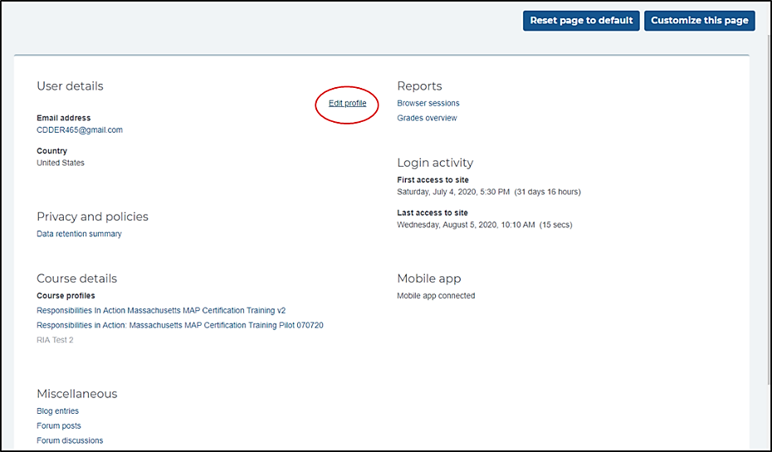
  - You will see your name, email address, etc. and this is where you can edit your name or email address if needed.
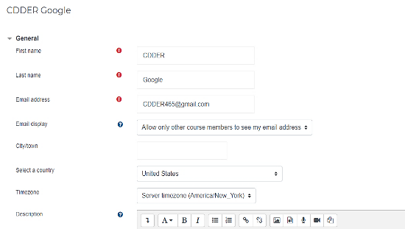
  - Click “Update Profile” at the bottom of the page to save your changes.
- If you change your email address or username, please contact CDDER@umassmed.edu and let us know for our records. You should also contact your MAP Trainer, so they have the updated information as well.
  - Make sure that the email address you are using for the course is one that is up to date and that you check regularly

The MAP RIA Course
After you login, you will see ‘MAP Courses’ along the top. Use the dropdown to select the MAP Certification Training.

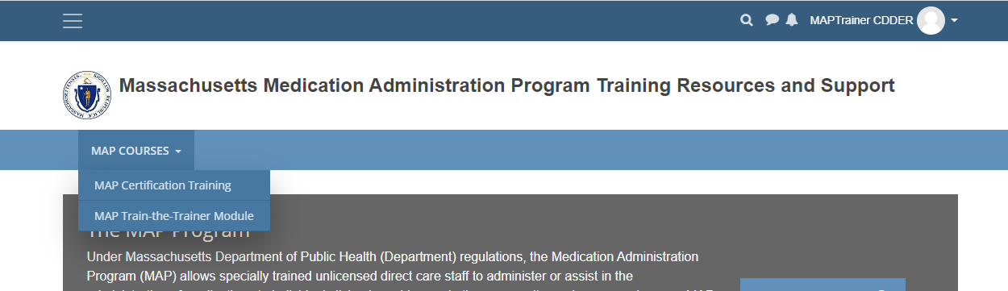

Home Page
This will open to the MAP RIA home page (also called a dashboard). Immediately clicking on the 3 bars in the upper left-hand corner (see image) will expand the viewing area for the course.
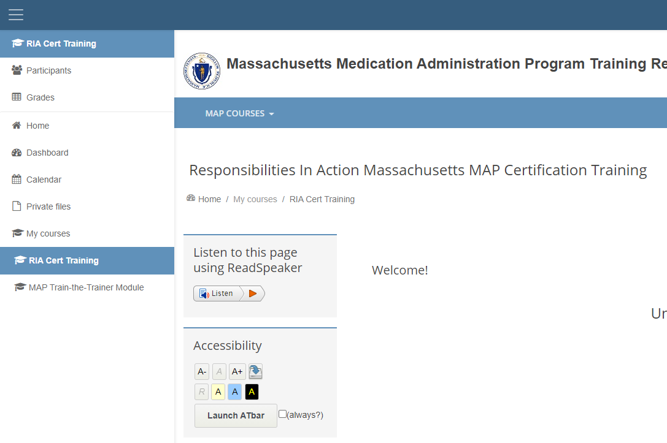

Accessibility Tools
Moodle has several tools to help you navigate the course.

ReadSpeaker is a text-to-speech tool that will read page content. You can highlight any text on your screen with your mouse and click the “Listen” button to have it read aloud.

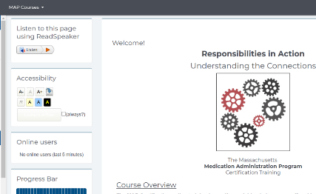

Accessibility Toolbar
This toolbar will increase or decrease the size of text on your screen. It does not affect the size of images. To enlarge images, use keyboard controls on your computer. Holding down the Ctrl key plus + or – will increase or decrease screen resolution on many machines.

The Accessibility Toolbar can also be used to add background color to text thereby making it easier to read.

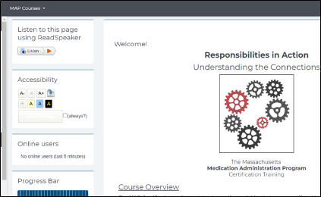

Your Courses
- How much has been completed in your courses?
Students need to complete each unit and pass the unit quiz at the end of the unit in order to continue with the course. The activity (unit or unit quiz) will automatically be registered as complete once the student has finished it. Students will see a green checkmark on the dashboard once the activity is complete.

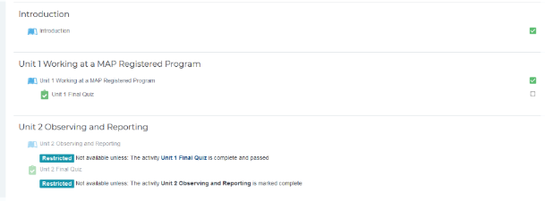

- The Progress Bar is a time-management tool for the student. It visually shows which Units and Quizzes a student needs to complete in the course. It is color coded so a student and the MAP Trainer can quickly see what they have and have not completed/viewed.

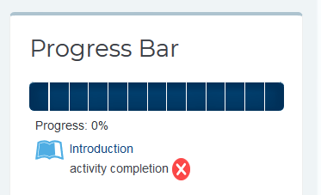

Forums
Moodle has two primary communication tools: Announcements and Discussion.
  - Announcements are a one-way communication tool for MAP Trainers to easily send news or updates to the students in their group. Students should periodically check this section for new Announcements. Student are also notified by email when a new Announcement is posted.
  - Discussion: This is a two-way communication tool for students and their MAP Trainer, or for other students in the same group. This is a great place for students to ask questions or seek additional clarification! Students are notified by email when a new discussion is posted, or if another student responds to a discussion post.

Both are located in the “Forums” block on the left-hand side of the dashboard.

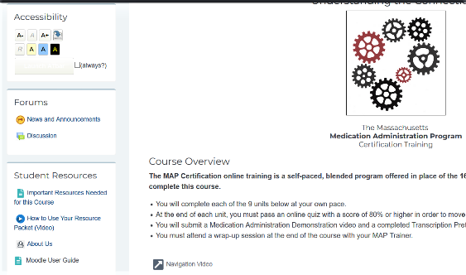

Students can “Add a new discussion topic” or reply to an existing one.

Messages
Moodle also has a messaging system when you can chat one-to-one with your MAP Trainer or other people in your group. It is located on the upper right-hand side of your screen, next to your profile.
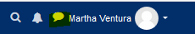

An alert will show when you have a new message.
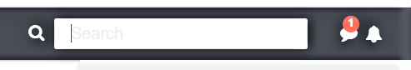

Students have the option of adding other students or MAP Trainers as contacts. If someone requests to add you as a contact, you will see a notification on the message bubble. After opening messaging, you will see a notification for the new request. You will also receive a notification via email that someone would like to add you as a contact.
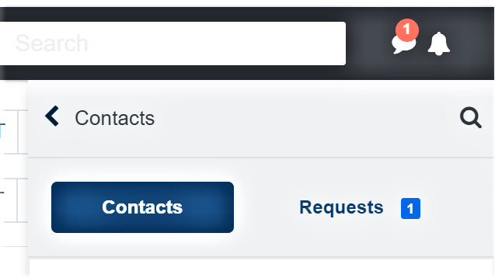

Under Privacy notification (gear icon), you can restrict messaging to only your contacts or to anyone in the course.
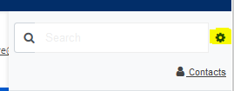

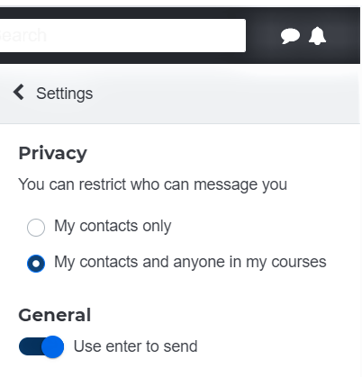

Knowledge Checks
There are several mini-quizzes and activities in the course that are called “Knowledge Checks”. You’ll see these in the units as you go along. Here are some helpful tips for doing the Knowledge Checks.
- Expand the viewing area by clicking the diagonal arrow in the bottom right corner. This makes the Knowledge Check exercise much larger!
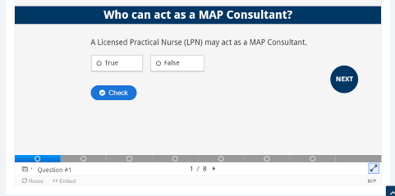
- You can navigate to the next slide by using the tool bar at the bottom, or the “Next” or “Back” buttons. Use the “Check” button to quickly see if your answers are correct. If your answers are incorrect, this will show you the correct answer.
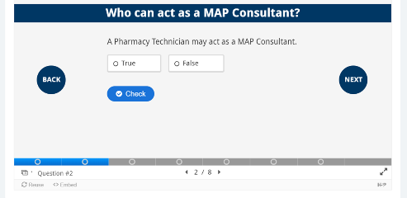
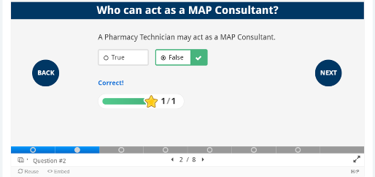
- Some of the Knowledge Checks contain images with lots of text. To read those images better, click on the “Click here to enlarge image” button to open the image in a new window on your browser. Use the keyboard controls on your computer to scale the image up or down. On many computers this done by holding down the Ctrl key and the + or – button.
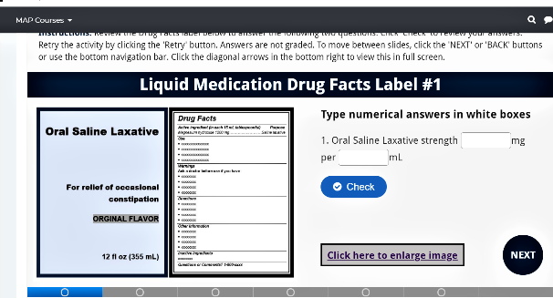

Quizzes
This course has nine unit quizzes that the student must pass with a score of 80% or higher. If you do not get 80% or higher, you can try again until you pass. Each quiz is available after completing the corresponding unit.

Begin the quiz by clicking on the “Attempt quiz now” button
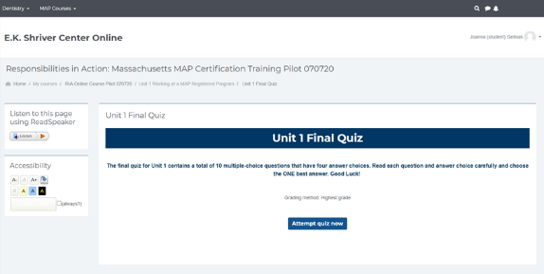

After you submit your answers, you will see a summary screen with your grade and an indication of which questions you missed. Red x’s next to an answer choice indicate that it is incorrect. Green checkmarks indicate that the answer choice was correct.

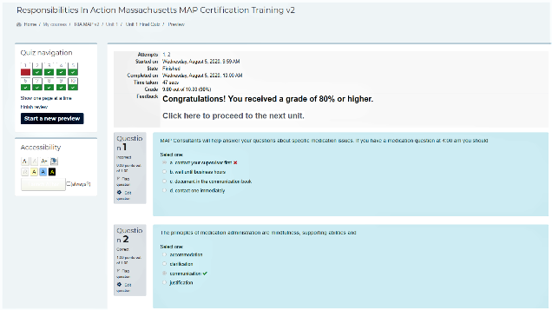

Checking Your Grades
Students can access their gradebook by using the dropdown arrow next to their profile and selecting “Grades”.

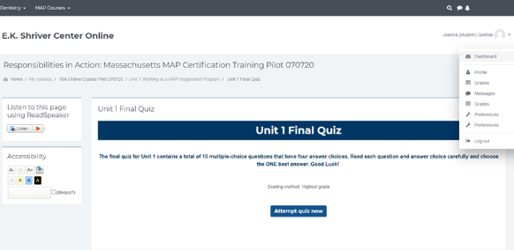

Here you will see grades for all the quizzes and other assignments

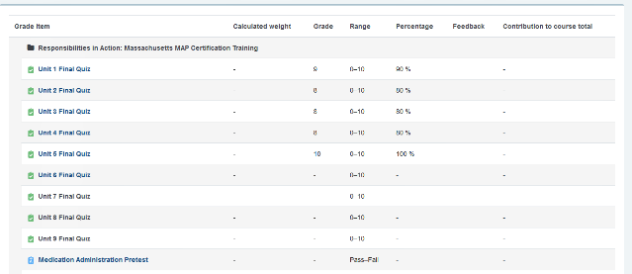

You will also see any feedback from your Trainer on graded assignments.
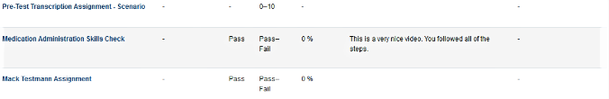

Course Wrap up
Once you’ve finished the nine units and quizzes, you are eligible to take the pretest components, by reading through the “Mandatory Pretest Instructions” and following the links there to each pretest component.

Finally, students should read through “Final Steps” and then complete the course evaluation.

THE END

Packets are available through Long Term Pharmacy Solutions (LTPS) for $10 per packet. To obtain a packet, email Carolyn Dunn at cdunn@ltps.us and include ‘Resource Packet’ in the subject line and include your mailing address with the request. In lieu of ordering a Resource Packet from LTPS, Service Providers may assemble their own Resource Packets. if interested, contents of the resource packets may be found at: https://shriver.umassmed.edu/online-map-certification-resource-packet-contents

